

PONDICHERRY UNIVERSITY

Department of Computer Science

MCA-I year

**IWT LAB PROJECT**

NAME : K.KATHIRARASAN

REG NO : 23352028

DEPT: MCA

DATE : 22/10/2024



**Movie Booking System Documentation**

**Table of Contents**

1. Introduction

2. Project Features

3. Technology Stack

4. Database Schema

5. System Flow

6. Payment Processing

7. Screenshots & User Interface

8. Future Enhancements

9. Conclusion



**1. Introduction**

The Movie Booking System is a web-based application that allows users to

browse, select, and book seats for available movies. The system includes a

simple yet effective interface for users to search for movies, select seats, and

proceed to make payments. Once the payment is successful, users are provided

with a receipt containing essential details such as seat numbers, movie

information, and the payment total.

**2. Project Features**

The system includes the following features:

• **User Registration and Login:** Users can create an account, log in, and

manage their bookings.

• **Search for Movies:** Users can search for movies using keywords.

• **Movie List:** A list of movies is presented to users, complete with images,

descriptions, and show times.

• **Seat Selection:** Users can choose seats from available options for a

particular movie.

• **Payment Gateway (Test Mode):** The system features a dummy payment

process for booking tickets.

• **Booking Confirmation:** Upon successful payment, the user receives a

receipt with booking details.

**3. Technology Stack**

The system uses a combination of front-end and back-end technologies for

seamless interaction:

• **Front-end:**

o HTML, CSS, and JavaScript for structure and interactivity.

o Bootstrap for responsive design.

• **Back-end:**

o PHP for server-side scripting.

o MySQL for database management.

• **Web Server:**

o XAMPP (Apache) is used for local testing and deployment.



**4. Database Schema**

The following tables are used in the system:

• **Users Table:** Stores user information such as username, email, and

password.

**Column Data Type Description**

id INT Primary key

username VARCHAR User's unique username

email VARCHAR User's email address

password VARCHAR Hashed password

• **Movies Table:** Stores movie details.

**Column Data Type Description**

id INT Primary key

title VARCHAR Title of the movie

image VARCHAR Path to the movie image

description TEXT Description of the movie

show_time TIME Time of the movie showing

• **Seats Table:** Tracks seat bookings.

**Column Data Type Description**

id INT Primary key

movie_id INT Foreign key referencing movies

seat_number VARCHAR Seat identifier (e.g., A1, B2)

booked_by VARCHAR Username of the person booking



**5. System Flow**

1. **Home Page:**

o Displays available movies with titles, descriptions, and images.

o Users can search for specific movies.

2. **Movie Details:**

o Upon selecting a movie, the user is taken to the movie's details

page, where they can select seats.

3. **Seat Selection:**

o The user selects the available seats from the layout displayed.

4. **Payment Processing:**

o After selecting seats, users enter their payment details in a dummy

form. The system processes the payment and updates the seat

availability.

5. **Booking Confirmation:**

o After payment, users receive a booking confirmation receipt.

**6. Payment Processing**

The payment process is implemented using a dummy payment gateway for

testing purposes. The user submits card details, which are not stored or

processed for real transactions but used to simulate a payment flow.

**Steps:**

1. Users select their seats.

2. The payment form requests card details and the user’s name.

3. Upon submission, the process_payment.php script updates the seats table

with the booked seat numbers and the user who booked them.

4. A receipt is generated with the following details:

o Movie title.

o Show time.

o Seat numbers.

o Total amount paid (including a tax estimate).

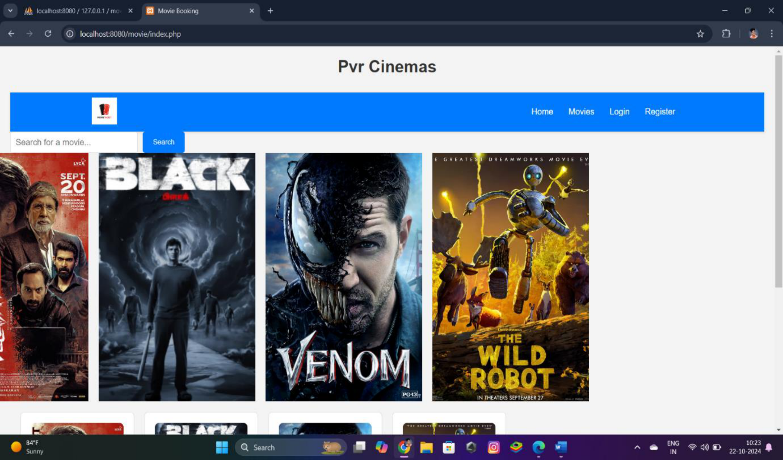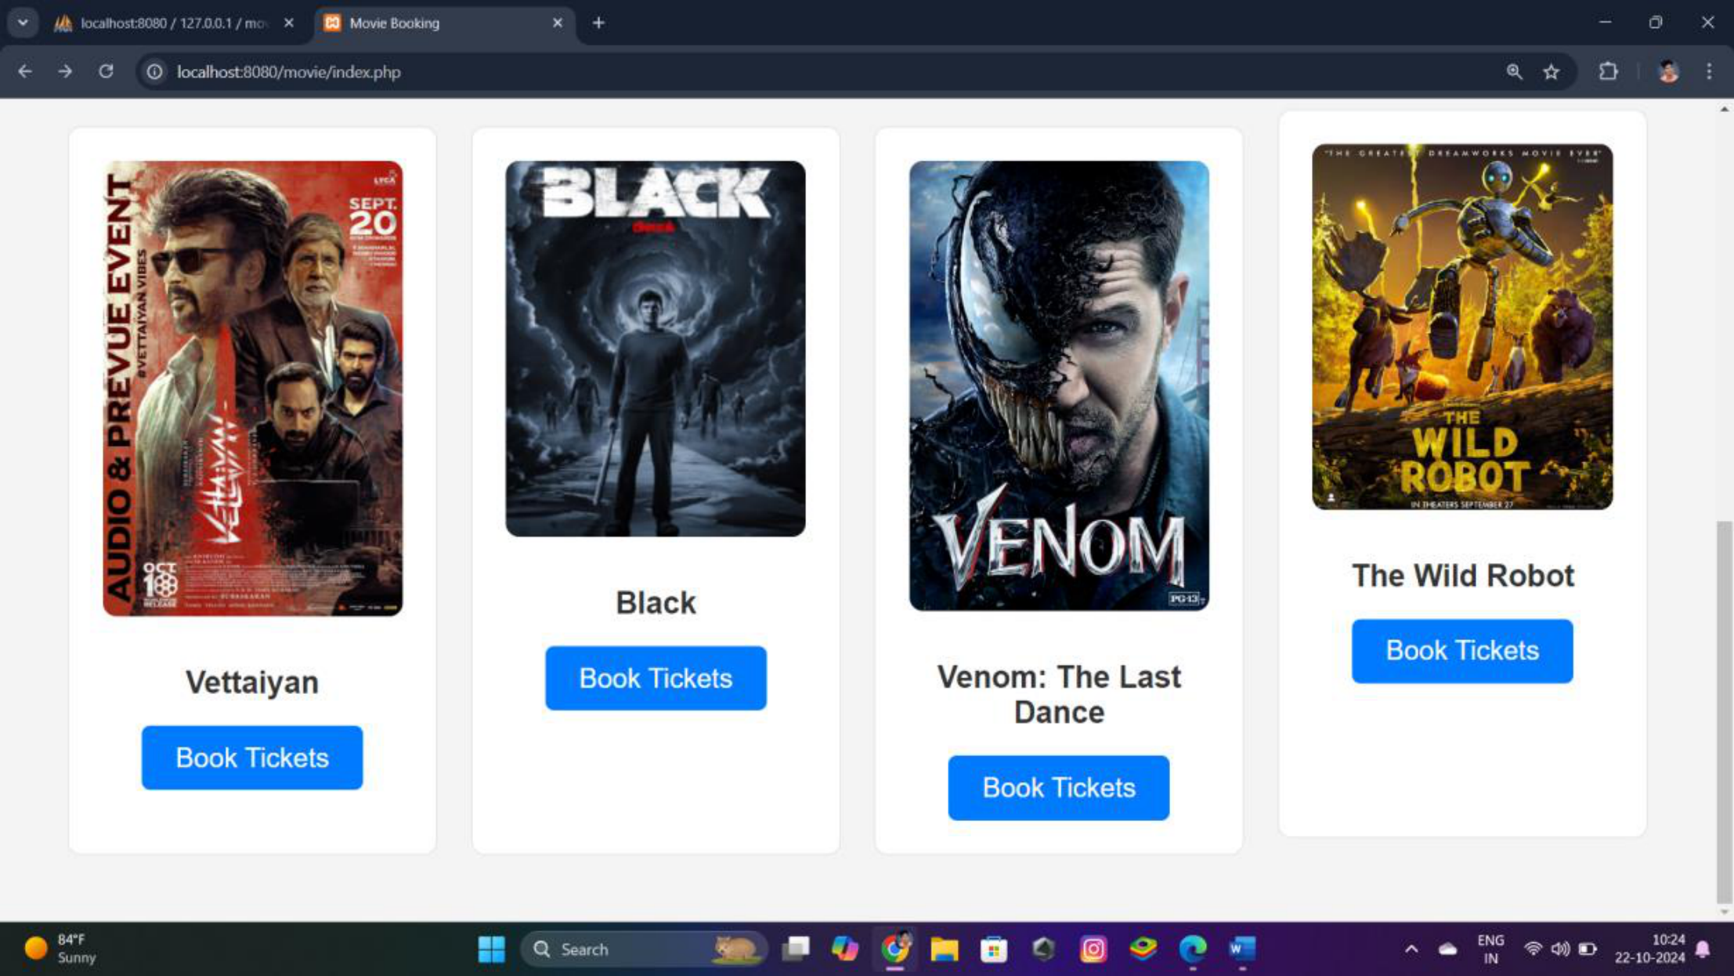

**7. Screenshots & User Interface**

**7.1 Home Page**

The home page displays a list of all movies, with search functionality.

**7.2 Movie Selection**

Movie details are shown with available seat options for booking.

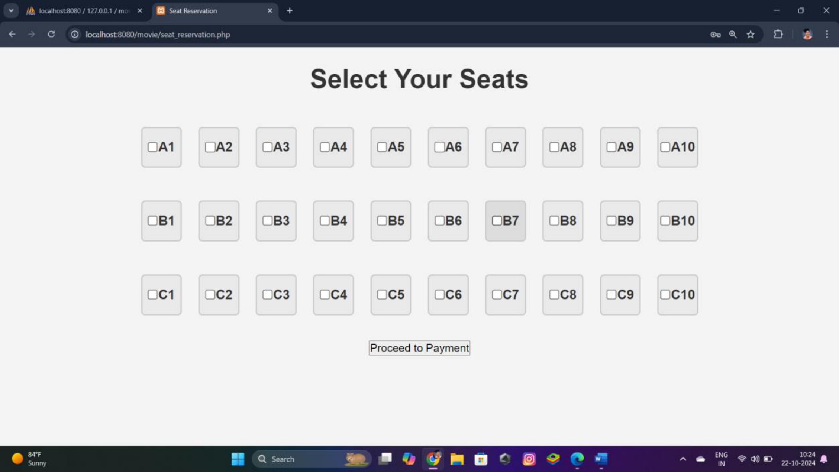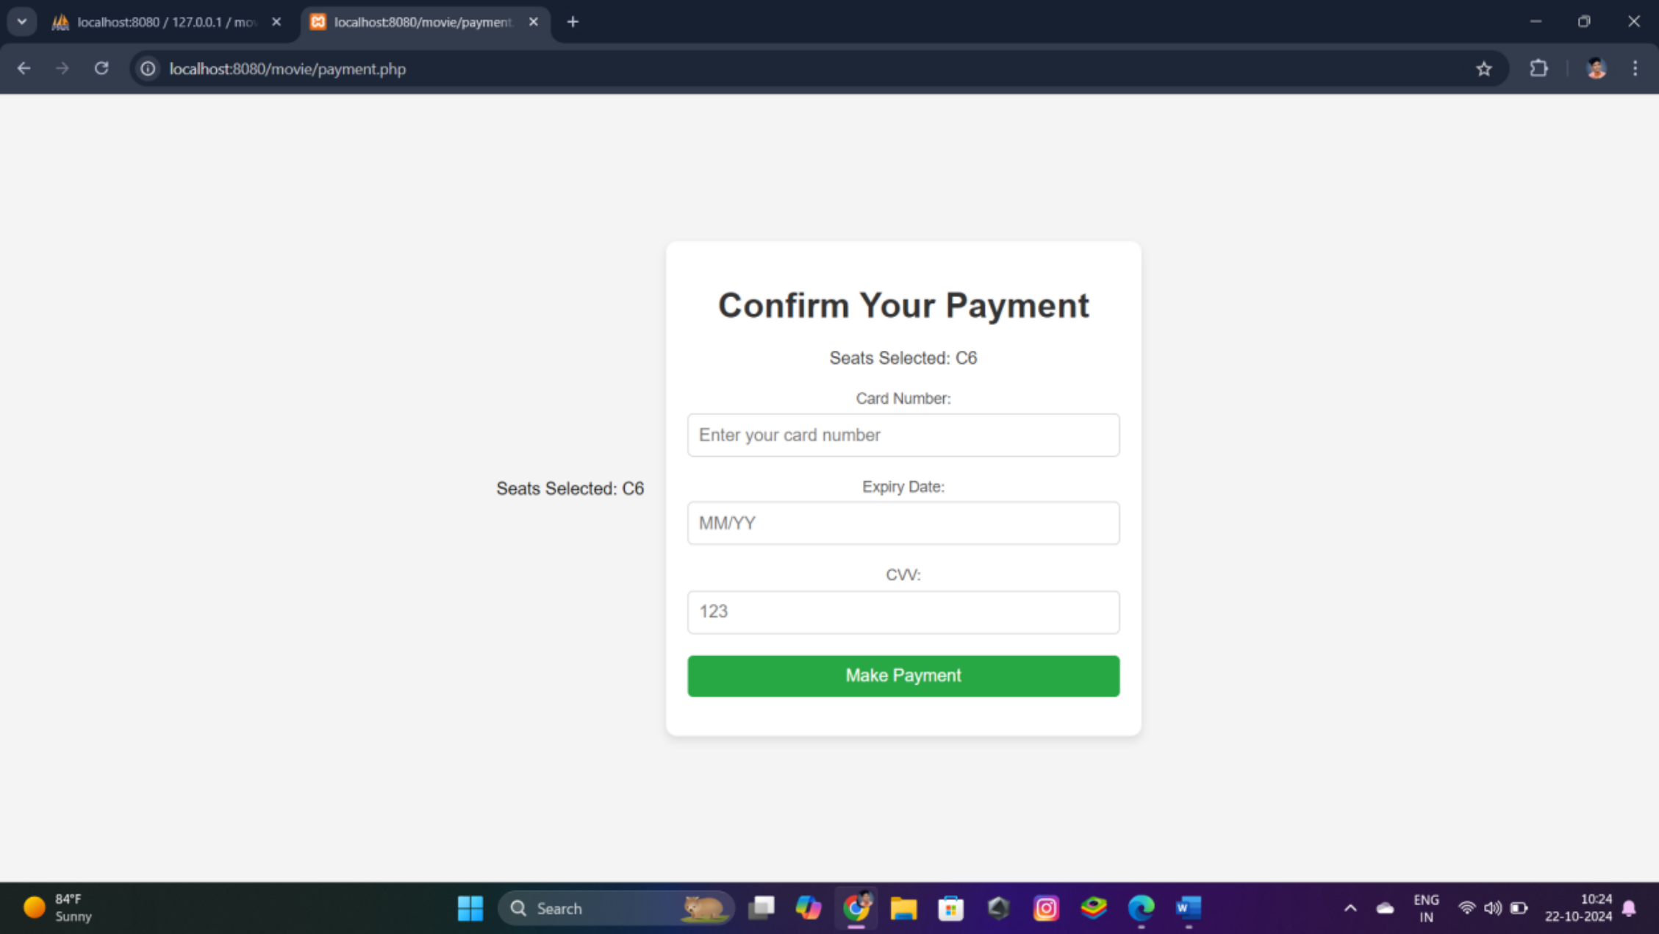

**7.3 Seat Selection**

Users can select seats for the movie from the available ones.

**7.4 Payment Form**

The payment form allows users to submit dummy card details.

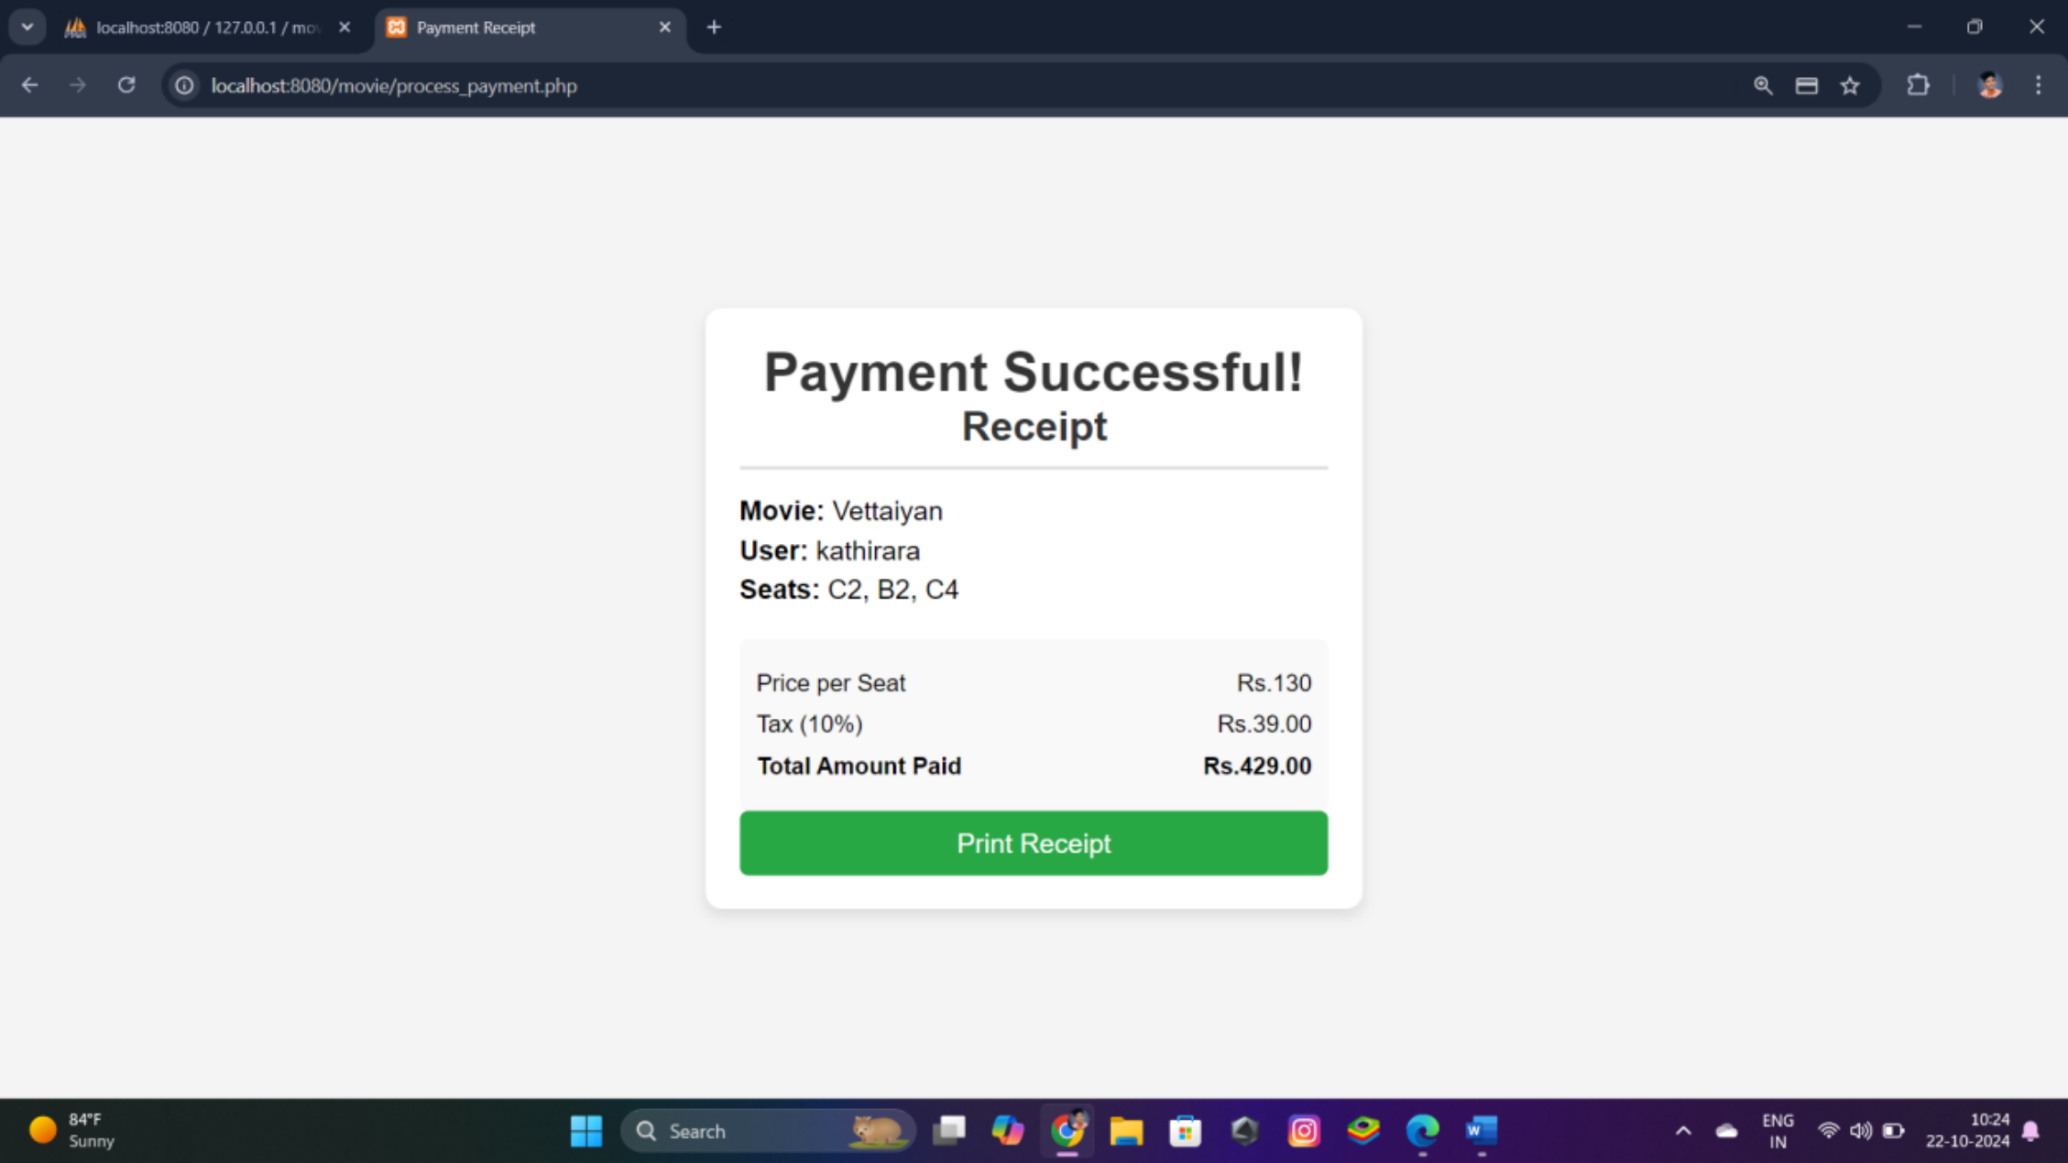

**7.5 Receipt Page**

Once payment is successful, a receipt page is displayed showing all relevant

details.



**8. Future Enhancements**

The following enhancements can be added in the future:

• **Real Payment Gateway Integration:** Implement a real payment

gateway (e.g., Stripe or PayPal) for actual payments.

• **Show Date Management:** Add a show_date column to support movies

with multiple dates.

• **Seat Layout Visualization:** Enhance the seat selection interface with a

more dynamic layout of available seats.

• **Booking History:** Allow users to view past bookings and download

receipts.

**9. Conclusion**

The Movie Booking System provides a streamlined user experience for

selecting and booking movie tickets. It offers a flexible platform for future

expansion and real-world application by incorporating additional features like

payment gateway integration and user management functionalities. The use of

PHP and MySQL ensures that the system is robust and can handle multiple

users and transactions efficiently.